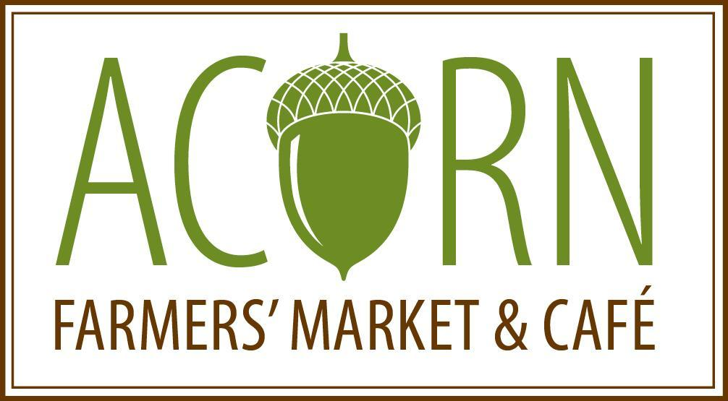

Dear Market Producer,

Thank you for your interest in selling at the Acorn Farmers’ Market & Café! Acorn’s mission provide access to fresh food and support the economic viability of area farmers by promoting education, collaboration, and entrepreneurship.

Acorn looks like a grocery store, but rather than purchasing the food at wholesale prices from vendors, products are sold on consignment directly from the producer to the customer. This model allows farmers and food makers to set their own prices and keep a greater portion of the final sale.

Acorn’s values:
- Providing fresh, nutritious foods that provide for the health of our community.
- Supporting farmers and producers local to Manchester first.
- Supporting production practices that are environmentally and socially responsible.
- Paying farmers a majority of each food dollar for their product.
- Ensuring equal access to fresh and prepared foods.
- Creating community-driven educational opportunities.
- Maintaining a beautiful and inviting place to gather and connect with others.

How Acorn Works:
- Open 7 days a week, 56-84 hours per week (except for holidays/according to season);
- Single Point of Sale System that allows the customer to easily purchase.
- Credit card processing, access to food access programs (double up food bucks, SNAP benefits, WIC).
- Refrigeration, freezers and limited storage capacity.
- Staff to display, maintain and rotate product.
- Staff refreshes and restocks produce from available supplies and will communicate sales and inventory supply information to producers.
- Works with producers to create signage for their store display, including information about their methods of production and farms / facilities.

Producer commitments:
- Producers will own and set the price for their products and may ask for guidance from staff.
- Producers will aim to provide a sufficient supply to match demand through deliveries at least once per week for perishable items, and as needed for non-perishable items. Maintaining availability of products is critical for customer satisfaction and returning business. The store has limited cooler and dry storage space which is available for producers to store inventory.
- Producers should plan how to best display and care for their products in the market. Products that wilt should be located in cooled areas, bagged, in water, etc.
- All products should be labeled with barcode labels (provided by Acorn) before leaving them at the market.
- Communicating with us about how to care for your products is a key to our success!
- Producers will be responsive and will be proactive in communicating changes.
- Producers will authorize Acorn to act on their behalf for replacement items and returns.

Eligibility:
- You consider yourself local to Acorn Farmers’ Market & Café or can directly deliver.
- If your product requires licensing you can provide a copy of current license
  - E.g. eggs, meats, dairy, any product that has been processed.
- Must have current liability insurance coverage for your business and provide a copy.

Application & Selection of vendors:
We accept a limited number of producers in each store category (vegetables, fruits, meat, dairy, grains, artisanal foods, ready-to-eat and non-perishables). Acorn staff selections will be made on a rolling basis, based on the following: product variety needed for store, quality, geographic proximity, sustainability, commitment to early and late season production, and vendor fitness for our model.

Process of becoming a vendor:
- Submit an application
- Submit any necessary license and/or insurance documents
- Submit a completed W9 form (https://www.irs.gov/pub/irs-pdf/fw9.pdf)
- Once application is accepted, our staff will be in touch directly
- Once approved as a vendor, we’ll set up:
  - Payment preferences (direct deposit suggested)
  - Donation or leftover product preferences;
- Communicate with vendor liaison on an on-going basis and bring product to Acorn during store hours.

Please fill out and return p. 3-6 of this application to vendors@acornfarmersmarketcafe.org.

KEEP THIS SHEET FOR YOUR RECORDS AND RETURN THE REST OF THE APPLICATION

ACORN PRODUCER APPLICATION 2022

Date submitted: __________________
Farm / Business name ________________________________________________
Contact name(s) ___________________________________________________________________
Street Address ___________________________________________________________________
Mailing Address ___________________________________________________________________
Phone _________________ Email ___________________________
Website ________________________________________
Preferred methods of communication (texting, mobile, e-mail)
#1________________________________ #2______________________________________________

Preferred method of payment (we recommend direct deposit which is the last page of this form.)
If by check, whom should we make it out to? IS the address the same as above? (Checks can be picked up only at the store.)
______________________________________________________________________________________

Please list products you would like to sell at the Acorn, along with anticipated timing (which months of year). (For produce, please fill out the grid on the last page):
______________________________________________________________________________________
______________________________________________________________________________________

Producer information (answer all that apply):
- What is your story? Please tell us about yourself and your business. When did you start, what is your vision for the next 5 years, what initiatives have you planned? What is your growth plan (other products you see yourself growing/making in the future)?
__________________________________________________________________________________________________________________________________________________________________________________________________________________________________________________________________________________________________________________________________________________________________________________________________________________________________________________________________________________________________________________
  - What is the acreage of your farm? __________
  - What is the acreage under production? _________

- Where else do you sell your products currently? (List markets, stores)
_________________________________________________________________________________________________________________________________________________________________________________________________________________________________________________________

- LEFTOVER PRODUCT: Please mark how you would like to handle any product that is expired or no longer consumable (wilted, moldy, etc) leftover from a delivery:
- Donate to the Community Resource Center or compost if no longer consumable;
- Please contact me if the product is expired or no longer consumable.

- PRODUCE: What best describes your growing practices. Check applicable boxes:
- Conventional
- Certified Organic If Certified Organic please attach a copy of your certification
- All Natural Not certified organic, but using only OMRI approved inputs.
- IPM Use Integrated Pest Management Practices, may use chemical fertilizer/pesticides/herbicides
- Hoop houses or other unique growing methods ___________________________
- Non-GMO Not using GMO products in our goods, feed or seed stock.
- Other (please describe) _____________________________________________
- MEAT: If you grow animals for meat, please give us a complete description of your growing practices. This assists us with vendor mix and marketing your product. This includes:

___________________________________________________________________

___________________________________________________________________

___________________________________________________________________

- EGGS: Please provide information:
  - What you feed your chickens (contains soy, GMO use, etc.) _______________________________

  - What do you want the customer to know about YOUR eggs? ______________________________
  - Are your eggs processed in a facility licensed by MDARD? YES NO

- PREPARED FOODS: What types of products do you make? Where do you make your products? Where do you source your ingredients? Please attach a copy of your license.
_________________________________________________________________________________________________________________________________________________________________________________________________________________________________________________________

- All producers must comply with local, state, and federal requirements regarding the production and sale of their products. See the Producer Guidelines for a list of the most common permits and licenses required of market producers. Attach copies of all licenses that apply.

- Acorn Farmers’ Market & Café, Inc. is not responsible for any loss or damage incurred by producers. It is required that producers carry general liability insurance, but it is the responsibility of each producer to insure themselves to the level they feel is appropriate, and indicate their coverage below:

____ General liability coverage of $_____________ (please provide proof of insurance) ____ No general liability coverage

I have read and understand the Acorn Farmers’ Market & Café Producer Guidelines, and agree to comply with all Acorn Farmers' Market & Café requirements. All information in this application is complete and accurate. I recognize that the goal of the Acorn Farmers' Market & Café is to help me sell my products and understand that this effort to grow the local food system will require flexibility and cooperation from everyone involved.

Signed _______________________________________ Date _____________________

*Produce vendor? Please fill out the next page.

Please email this application to vendors@acornfarmersmarketcafe.org.
Questions? Call our Vendor Liaison at 989-430-0926.

This form is to be filled out if you are approved as an Acorn producer.
Don’t fill out unless your application has been confirmed
and you want direct deposit.

Acorn Farmers’ Market & Café, Inc
Direct Deposit Authorization

I (we) hereby authorize Acorn Farmers’ Market $ Café, hereinafter called “COMPANY”, to initiate credit entries and, if necessary, debit correction and adjustment entries to my (our) account at the financial institution listed below, hereinafter called DEPOSITORY. I (we) acknowledge that the origination of ACH transactions to my (our) account must comply with the provisions of U.S. laws and regulations.

Bank
Name

Routing & Account
Transit Number Number

Account Type: □ Checking/Draft □ Savings/Share

This authorization is to remain in full force and effect until COMPANY has received written notification from the signer(s) below of its termination in such a time and manner as to afford COMPANY and DEPOSITORY a reasonable time to act upon it.

Business Name
(Please Print)

Name on Account
(Please Print)

Date Signature(s)

Please attach a voided check to this form.

Note: Written credit authorization must provide that the receiver may revoke the authorization only by notifying the originator in the manner specified in the authorization.

